PTO Sell Back Instructions:
1. Sign on to Employee Self Service (ESS) and select “PTO Sell Back” from the drop-down menu.
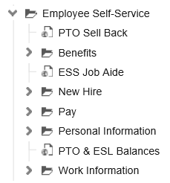
Step 1
2. Under the “Hours Requested” field, select the amount of hours you want to request from the drop-down menu.
3. Click on the submit button on the top left-hand corner. You will receive an automatic email confirmation to your Cooper email account.
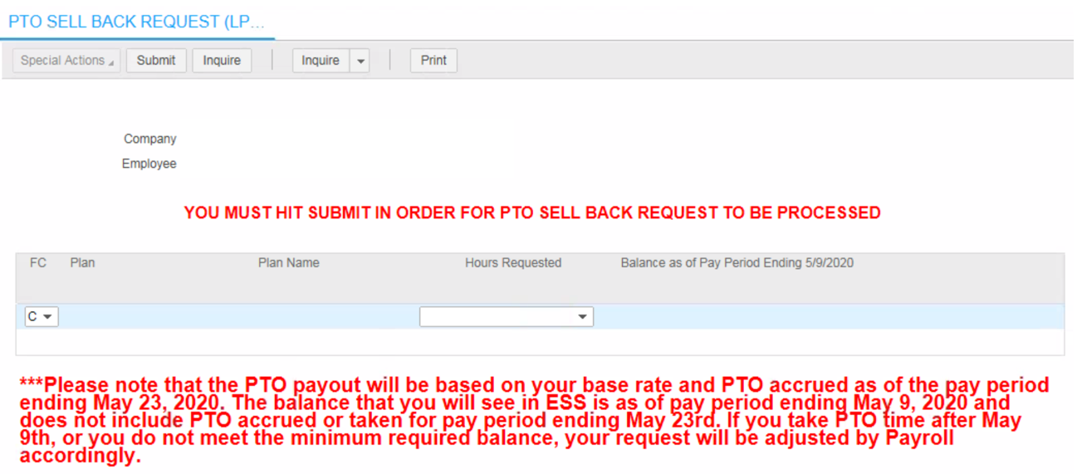
Step 2
Step 3

If you are amending your original sell back hours, you must enter the total hours you are requesting, not the additional amount. Previous submissions will be overwritten.

Example – You submit a request for 16 hours and then decided to request 24 hrs.
You must submit a second request for 24 hours. Your first request for 16 hours will be overwritten, and you will receive 24 hours of PTO payout.

All requests must be submitted between May 18, 2020 at 7am and May 29, 2020 at 5pm.

